TASK 23
DEPLOY MACHINE ANOMALY DETECTOR TO EC2 INSTANCE

- AWS EC2 Instance Creation and Configuration

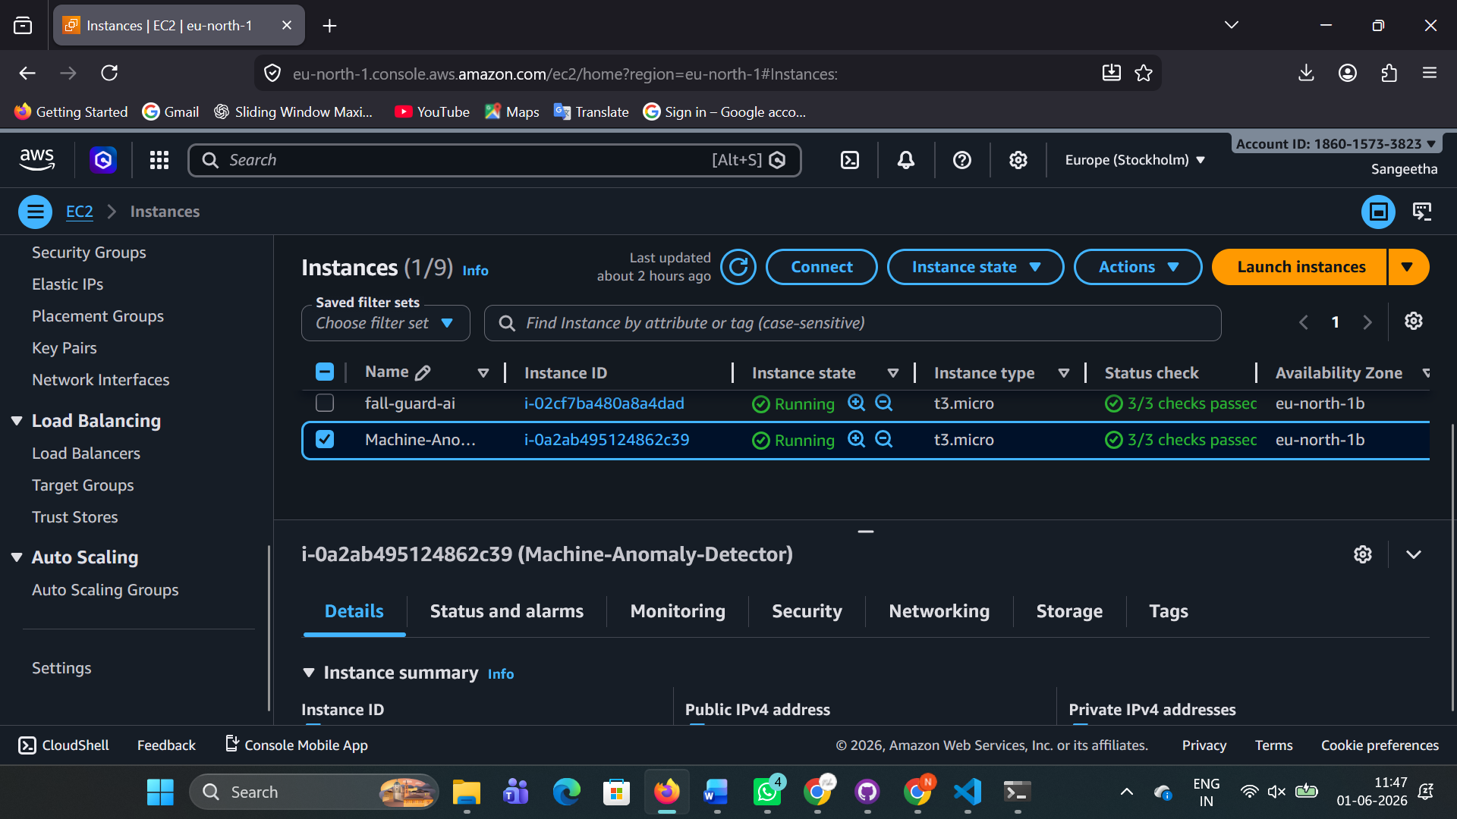

- Flask Backend Deployment on Ubuntu EC2 Server

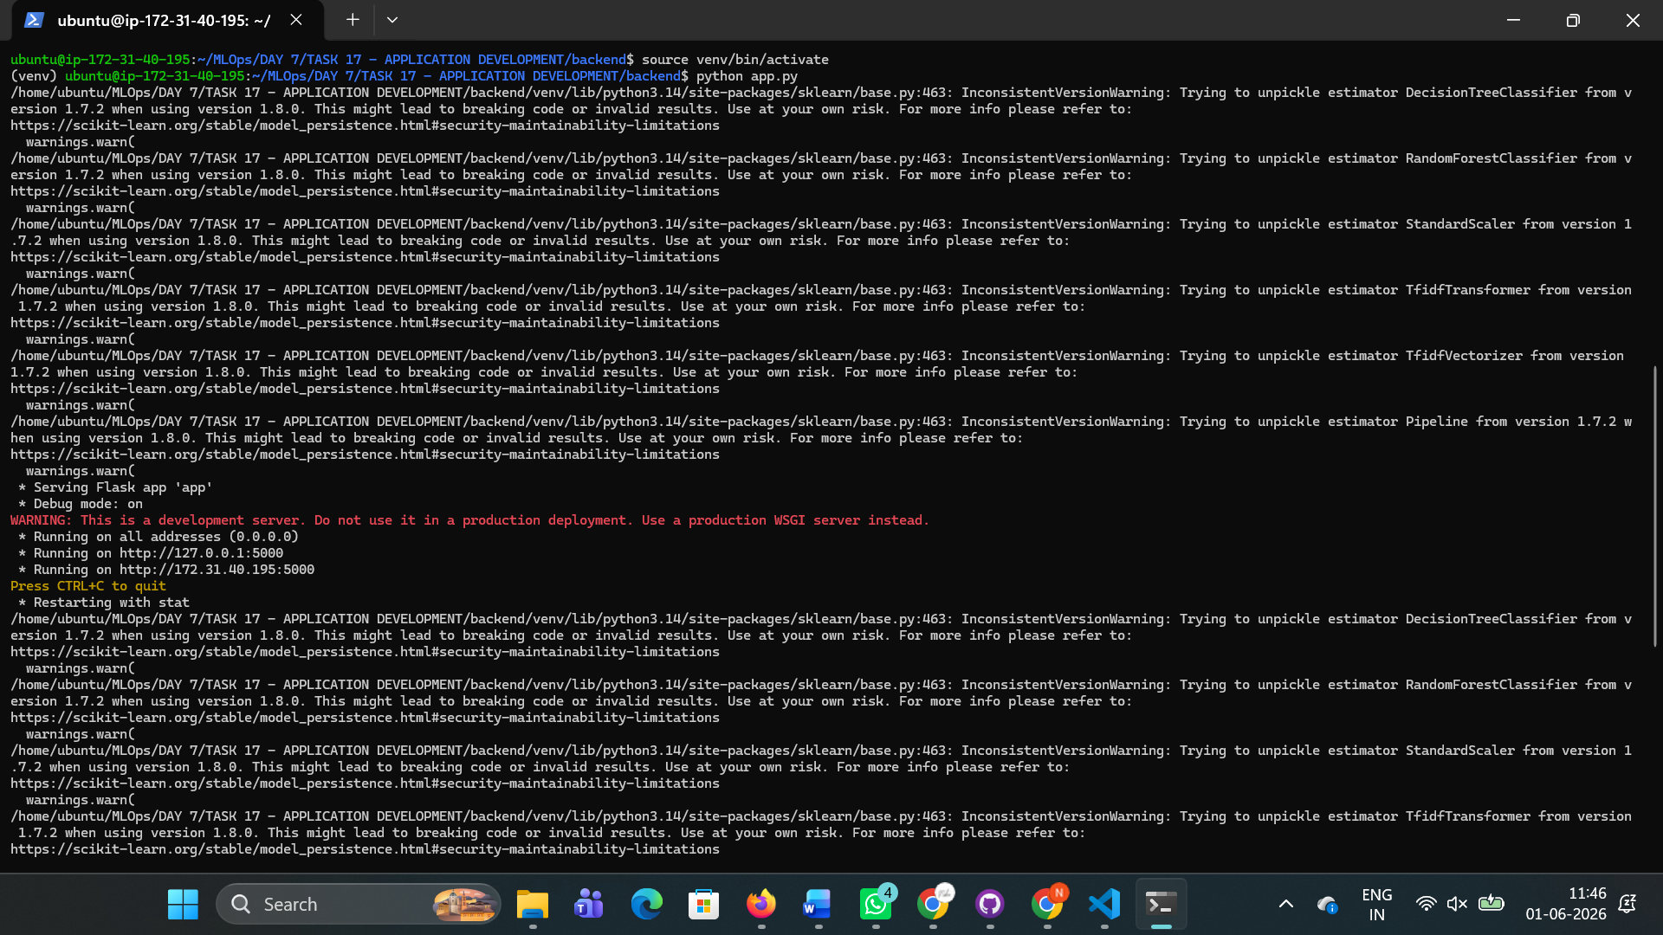

- Smart Factory Anomaly Detector Application Running on AWS Cloud

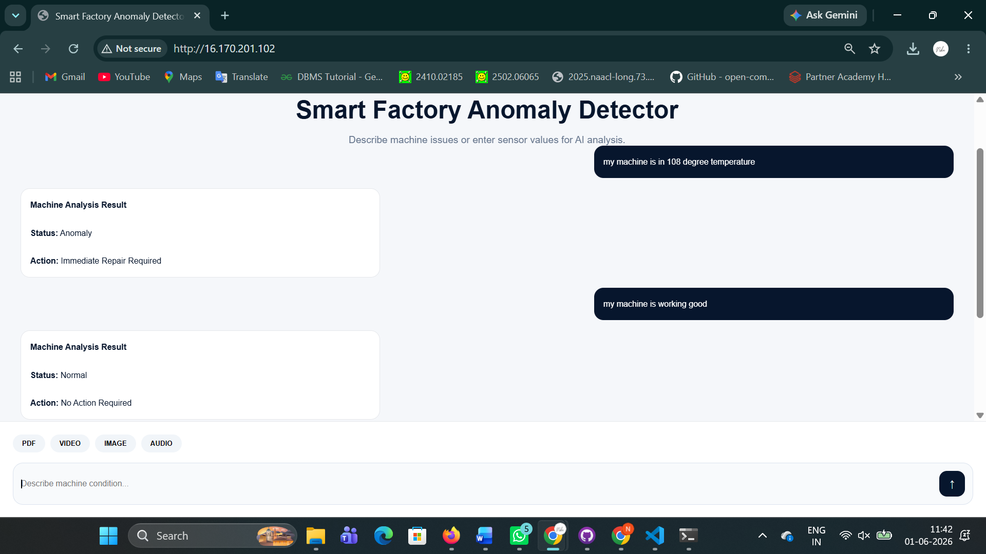

LIVE SERVER : http://16.170.201.102/

